

**Bharatiya Vidya Bhavans’**

**Sardar Patel Institute of Technology Munshinagar, Andheri(W), Mumbai-400058 (Autonomous College Affiliated to University of Mumbai)**

**Academic Year: 2025 26 Semester: III Class: MCA**

**Course Code: MC520 Course Name: Cloud Computing**

**Experiment No.3**

**Date**: 24.09.25

**Aim: Ubuntu: Development of Automation using Ansible**

CO Mapping – OECS1.4

**Objective**:

To learn and implement IT automation in Ubuntu using Ansible for configuration management, application deployment, and task orchestration, enabling efficient, repeatable, and scalable system administration.

**Concept**:

Ansible is an open-source IT automation tool used for configuration management, application deployment, and task automation.

* It uses a declarative YAML-based language (Playbooks) to define tasks.
* Operates agentlessly — communicates with target systems via SSH, so no special software is needed on clients.
* Ensures consistency, scalability, and repeatability of system configurations.

**Lab Exercise**:

1. **Create a Spring Boot Project**

* Develop a normal Spring Boot application (for API).
* Build the project using Maven/Gradle to generate the JAR file.

1. **Create Inventory File (inventory.ini)**

Add the ip address of your machine in **inventory.ini.** you can get it using: - ip addr

1. **Create Ansible Playbook (playbook.yml)**

---

- name: Deploy and run Spring Boot app locally

hosts: localhost

connection: local

become: yes

vars:

app_name: project-0.0.1-SNAPSHOT.jar

app_dir: /opt/springboot

java_package: openjdk-17-jdk

app_user: atharva

app_group: atharva

tasks:

- name: Install Java

apt:

name: "{{ java_package }}"

state: present

update_cache: yes

- name: Create app directory

file:

path: "{{ app_dir }}"

state: directory

owner: "{{ app_user }}"

group: "{{ app_group }}"

mode: '0755'

- name: Copy Spring Boot JAR to local directory

copy:

src: "./project/target/{{ app_name }}"

dest: "{{ app_dir }}/{{ app_name }}"

owner: "{{ app_user }}"

group: "{{ app_group }}"

mode: '0755'

- name: Run Spring Boot app in background

shell: "nohup java -jar {{ app_dir }}/{{ app_name }} > /dev/null 2>&1 &"

args:

chdir: "{{ app_dir }}"

async: 0

poll: 0

1. **Run the Playbook**  
   Execute the following command in the terminal:

ansible-playbook playbook.yml -k

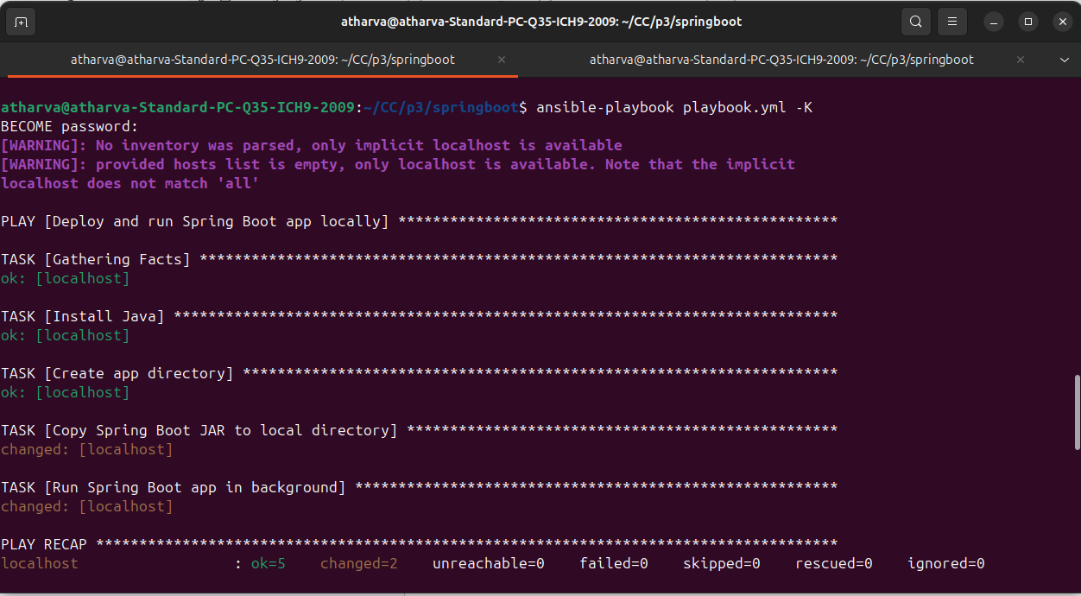

1. **Verify Deployment**

Once the playbook runs successfully, check the Spring Boot API on port 8080 (default port specified in the project).

You can use Postman to verify you api.  
  
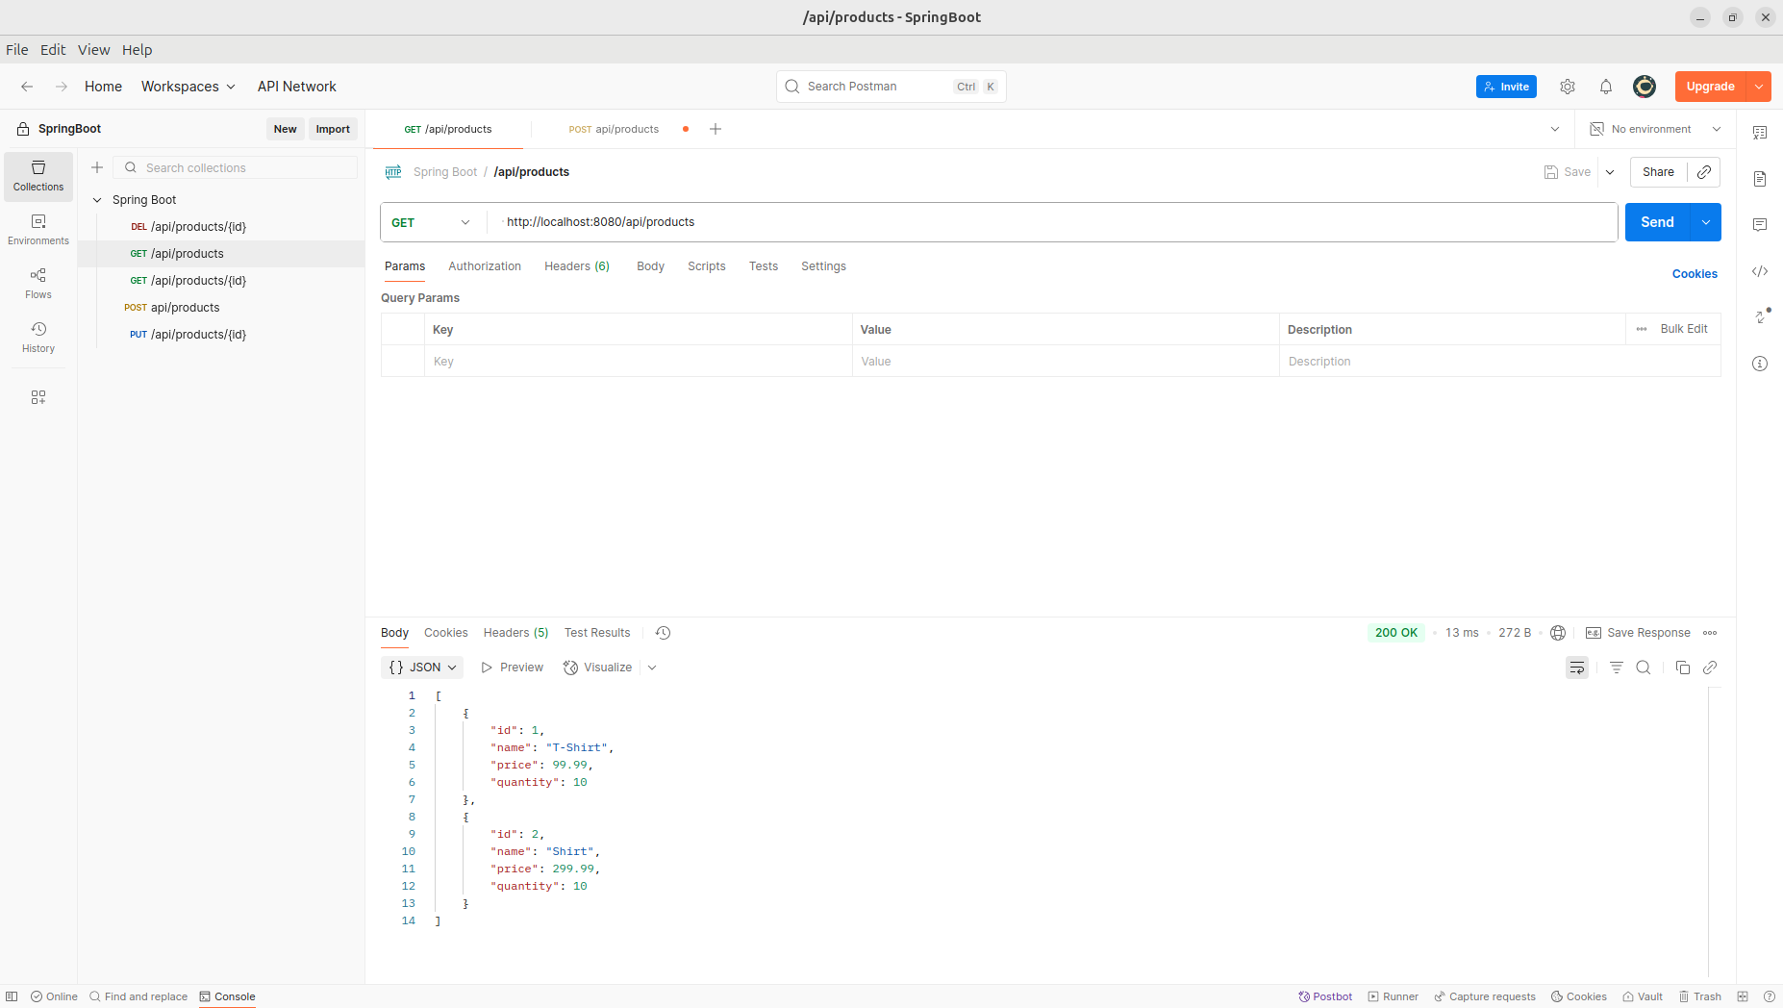

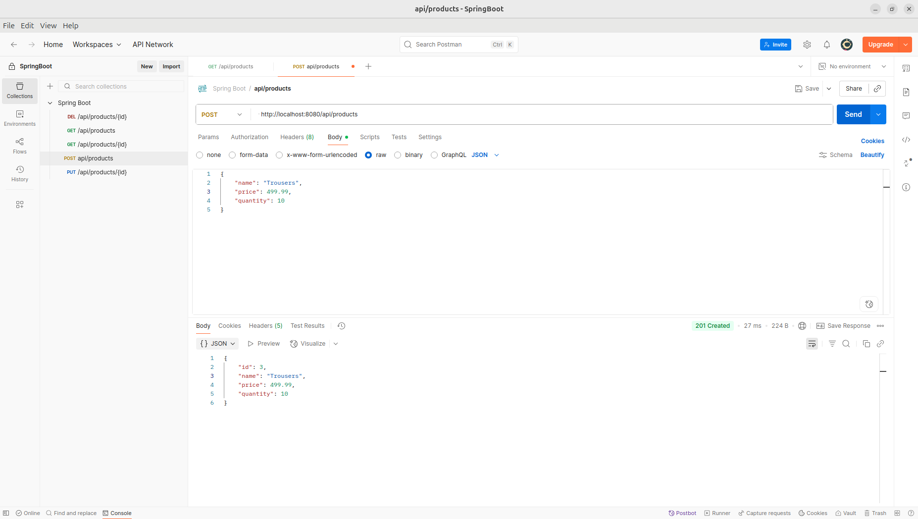

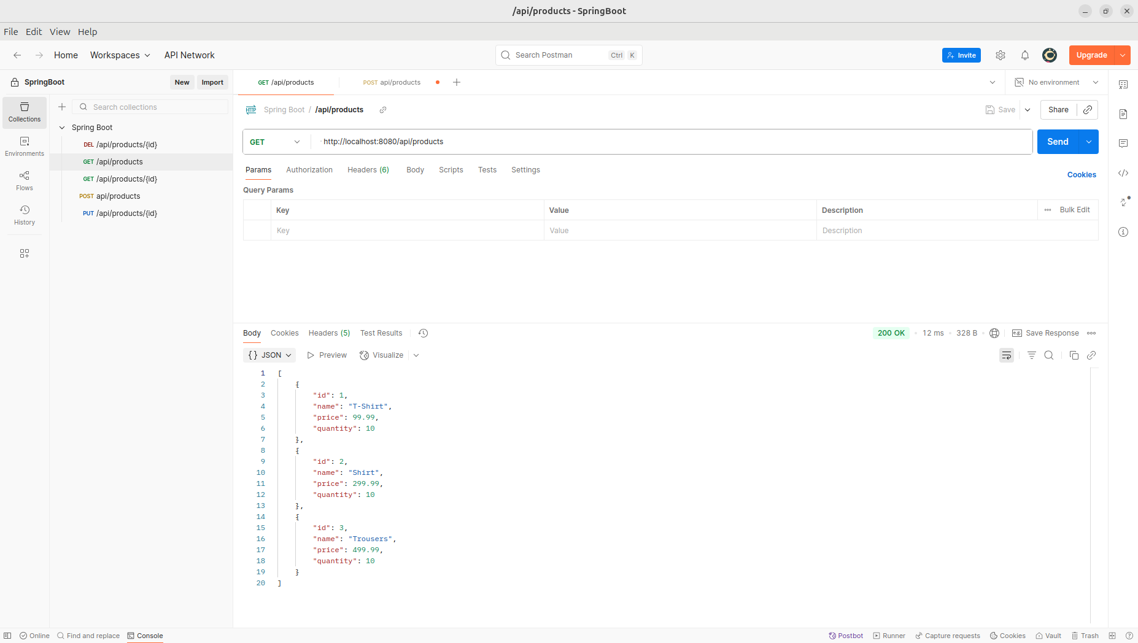

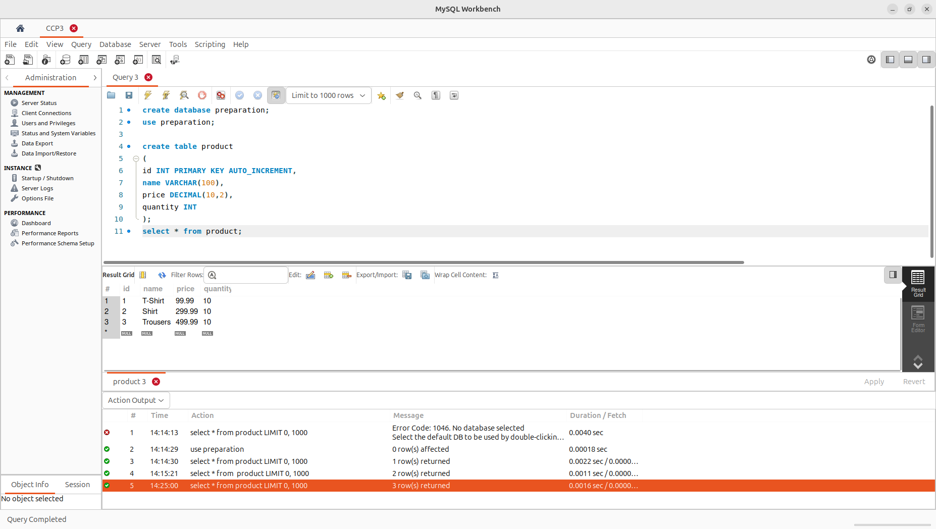

**Observation**:

The Ansible playbook executed successfully and automated the installation of Java, creation of the app directory, and deployment of the Spring Boot JAR.

The Spring Boot application started in the background and the API was accessible on port 8080.